MEDIA RELEASE
EMBARGOED UNTIL 1700 ON 25/7/17
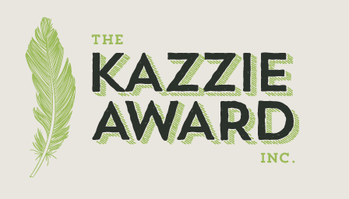
Four Kazzie Awards Announced for outstanding efforts in environmental protection

Four recipients were announced, at the Keep Australian Beautiful Litter Congress, for demonstrating outstanding passion and efforts in environmental protection and litter prevention. The four programs include educational workshops to groups in Cambodia about reducing use of plastics, a grassroots community campaign encouraging residents and businesses of Ryde NSW to take simple steps to waste less, working with the Bellingen community to minmimise litter and move towards a zero waste town, and in Exmouth WA community outreach and grassroots change project targeting reduced use of single use plastics.

Thirty applications were received from women dedicated to protecting the environment, and who receive little recognition and few resources to fulfil their dreams. Applicants came from Victoria, NSW and Western Australia and internationally from New Zealand, Cambodia and the United Kingdom.

The Kazzie Award was created to honour Karen Curnow (Spehr) and is funded by the memorial fund established soon after Karen’s death in June 2017. The Kazzie Awards aims to provide practical assistance to unsung heroes in a wide a range of community development areas.
Lindsay Curnow president of the Board said, “it is heart warming to see so many women working so hard on improving our world. We wish we had enough funds to support all these wonderful initiatives. We will keep raising funds, to ensure we can continue to support unsung environmental heroes.”
All 30 applicants will be recognised on the Kazzie Award honour roll, which can be found at www.kazzieaward.com.au
Kazzie Award recipients announced at Keep NSW Beautiful Litter Congress on Tuesday 25th of July will be presented by Joan Curnow Karen’s mum with War on Waste's Craig Reucassel (http://knswb.org.au/our-programs/congress-program/). Recipients will also receive a personalised art piece created by Jo Postlethwaite, a ‘litter removalist’ who recovers materials and lovingly combines them with other reused items to make beautiful pieces.
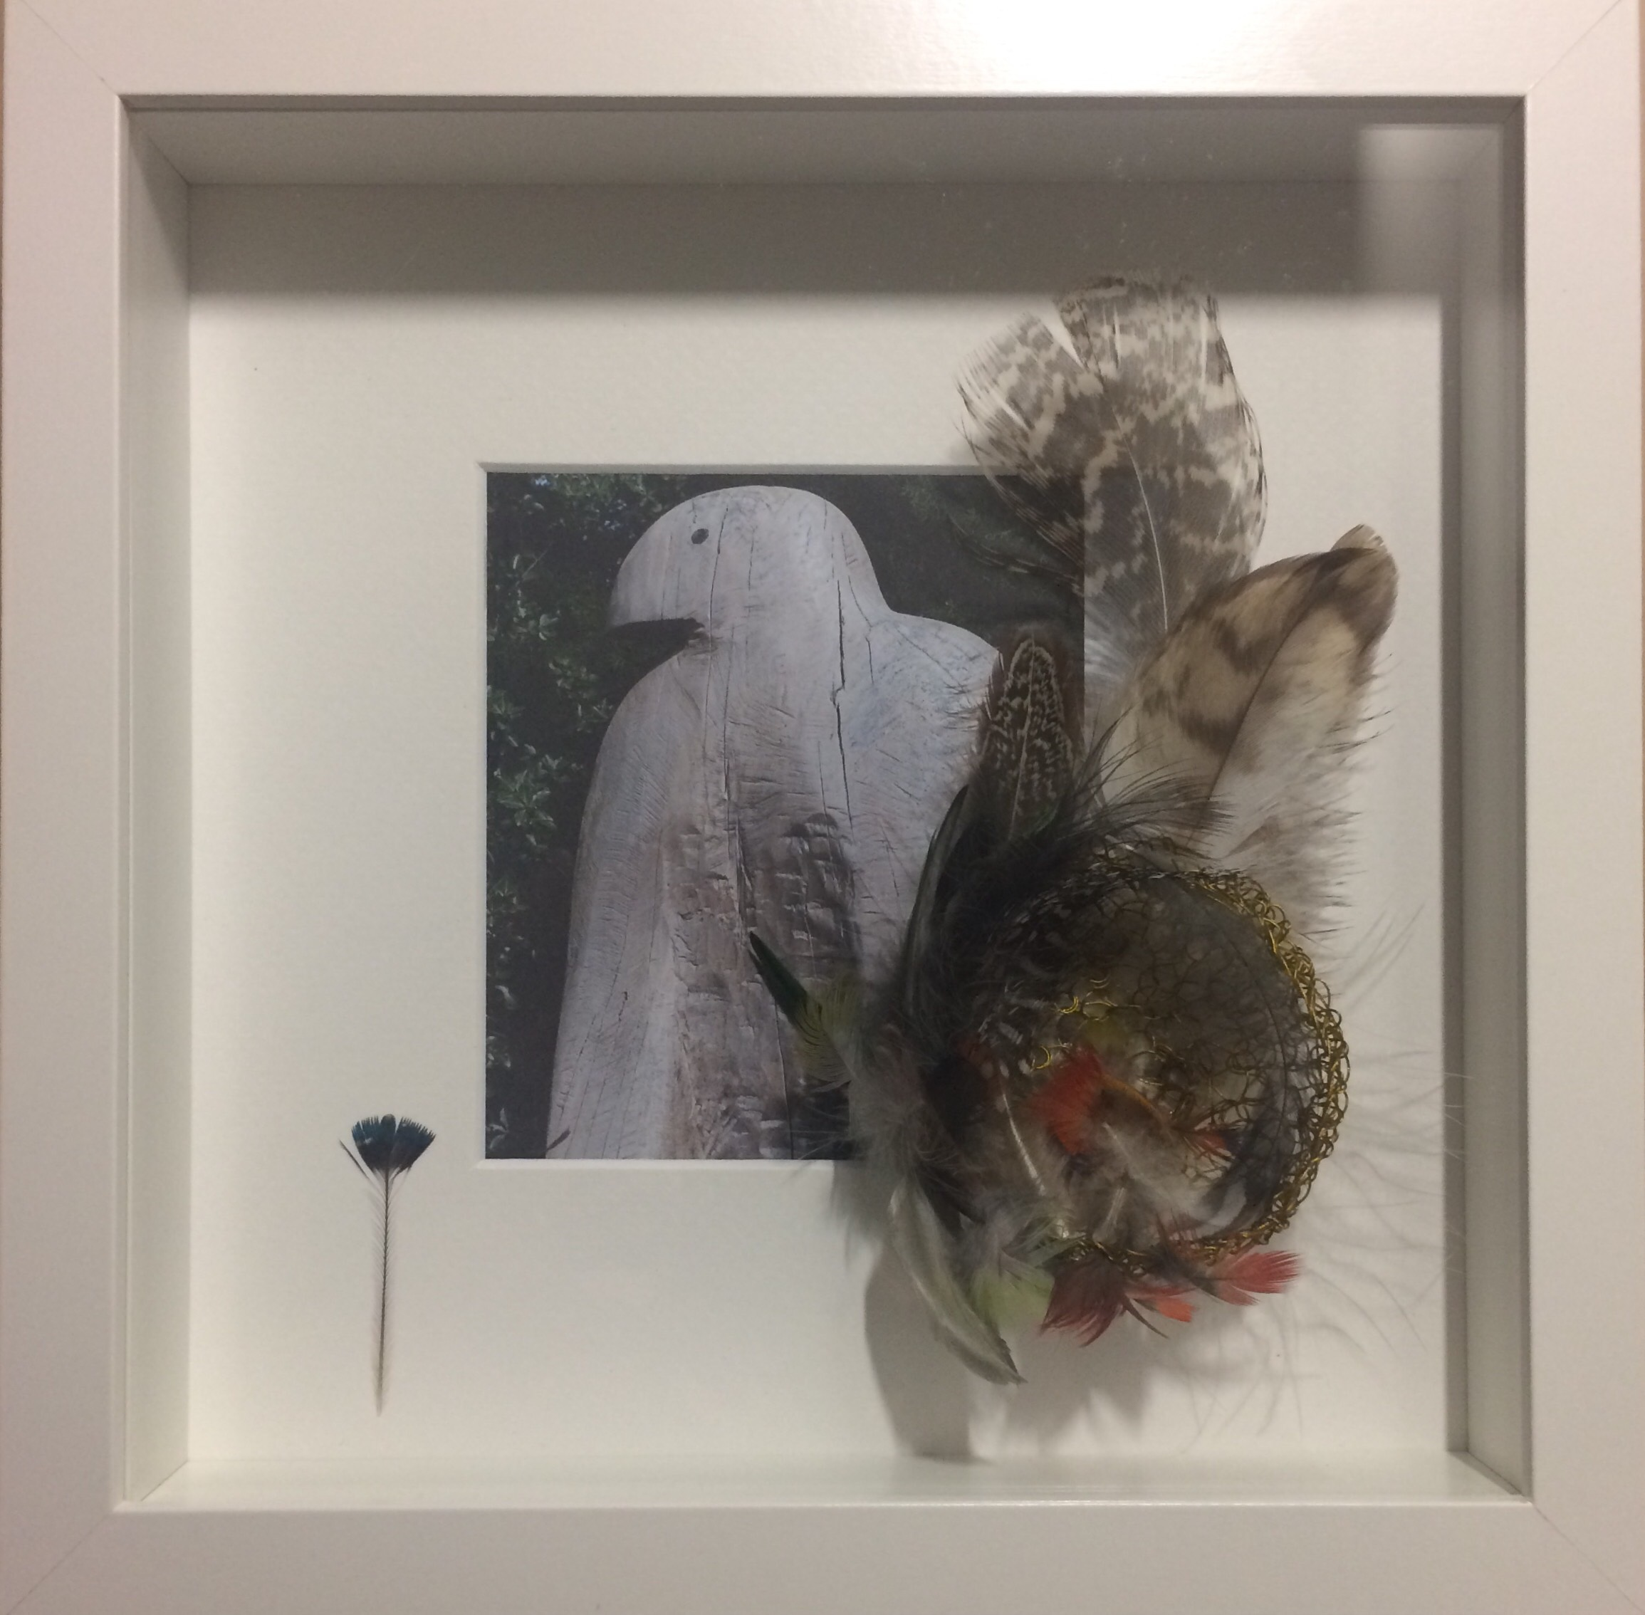

The 2017 recipients are:
Sarah Rhodes Cambodia plasticfreecambodia@gmail.com tel +855 (0) 70 970 536
My project provides educational workshops to groups in Cambodia about reducing use of plastics. We have been running using volunteers for the last two years, and this funding will employ someone in a full-time position for 6 months. With education, we can minimise waste - specifically plastic waste - being thrown away and burned in Cambodia and this is my mission and why we began the Plastic Free Cambodia program.

Joanne Taranto and Corina Seeto, Ryde NSW, email joanne@taranto.tv tel 0419689041
Joanne and Corina are the co-founders of '5 for Ryde', a grassroots community campaign encouraging residents and businesses of Ryde, NSW to take 'simple steps to waste less.
las@westnet.com.au
Alice Forrest, Exmouth WA email alicekforrest@gmail.com tel 61451264059
Inspiring change through workshops, community outreach and grassroots change by targeting single use plastics as a way of life. I want to advance environmental protection by giving people the power to change, and helping them to do so.
Lisa Siegel – Belligen NSW email las@westnet.com.au tel 0423 362 844
Lisa is a passionate advocate for working with her community towards a zero waste town. The Waste Not Bellingen initiative enables deep behaviour change through research, strategic planning, partnerships, and community engagement. The Waste Not story will be documented to inspire other communities to shape their own zero waste futures.
The Kazzie Award would like to thank everyone who has donated to the Karen Curnow Women in Environment Protection and Litter Prevention Memorial Fund at www.gofundme.com/karencurnowfund to make the award possible.
Donations continue to be accepted and applications for next year will open in May 2018.

- Ends –
For more information visit http://kazzieawards.com.au.

MEDIA SPOKESPERSON AND ENQUIRIES
Rob Curnow, Secretary of the Karen Curnow (Spehr) Women in Environment Protection and Litter Prevention Memorial Fund and Director of Community Change
Phone: 61 3 9775 4422 Mobile: 0418 885 312

http://kazzieawards.com.au
rob@communitychange.com.au
www.communitychange.com.au
www.litterology.com.au

